A MINI PROJECT REPORT
ON

A Study on Various Type of Skin

SUBMITTED TO AN AUTONOMOUS INSTITUTE, AFFILIATED TO SAVITRIBAI PHULE PUNE UNIVERSITY, PUNE IN THE PARTIAL FULFILLMENT OF THE REQUIREMENTS
FOR THE AWARD OF THE DEGREE OF
T.Y. BACHELOR OF TECHNOLOGY
CSE (DATA SCIENCE)

SUBMITTED BY

Atharv Deshmukh Roll No: 12
Jayesh Chaudhari Roll No: 22
Vivek Singh Roll No: 56



DEPARTMENT OF CSE (DATA SCIENCE)

G H RAISONI COLLEGE OF ENGINEERING AND MANAGEMENT

WAGHOLI, PUNE 412207

2025-26



CERTIFICATE

This is to certify that the Mini Project report entitles

A Study on Various Type of Skin

Submitted by
Atharv Deshmukh Roll No: 12
Jayesh Chaudhari Roll No: 22
Vivek Singh Roll No: 56

are a bonafide students of this institute and the work has been carried out by them under the supervision of Prof. Hemant Chaudhari and it is approved for the partial fulfillment of the requirement of An Autonomous Institute, Affiliated to Savitribai Phule Pune University, for the award of the degree of T.Y. Bachelor of Technology in CSE[ DATA SCIENCE] in the academic year 2025-26.

(Prof. Shreya Kokade) (Prof. Rahul Borate)
Guide Mini project Coordinator

(Dr. Deepika Ajalkar) (Dr. N. B. Hulle)
H.O.D. I/C Director
GHRCEM, Pune

Date:
Place: Pune

ACKNOWLEDGMENT
It gives us great pleasure in presenting A Study on Various Type of Skin Diseases as our T.Y. B.Tech. Mini project. Words have never seemed as inadequate as now when we are endeavoring to express our gratitude at the culmination of our T.Y. B.Tech. Mini project to all those who have made it possible. Even the best efforts are waste, without the proper guidance and advice of our project guide Prof. Shreya Kokade for the consistent guidance, co-operation, inspiration, practical approach and constructive criticism, which provided us the much needed impetus to work hard & also thanks Dr. Deepika Ajalkar Head of CSE (Data Science) Department for their continuous support & valuable suggestions.
We take this opportunity to thank our I/C Director Dr. N. B. Hulle for their whole hearted support, motivation & valuable suggestions.
We would also like to thank Prof. Rahul Borate our Mini project Coordinator for her valuable support in providing us with the required information.

At the end, we would like to give special thanks to all staff members from of CSE (Data Science) of G H Raisoni College of Engineering and Management, Pune & our colleagues for their kind support & timely suggestions.

Atharv Deshmukh Roll No: 12
Jayesh Chaudhari Roll No: 22
Vivek Singh Roll No: 56

ABSTRACT
In recent years, Artificial Intelligence has emerged as a powerful tool in the field of healthcare, particularly in the early detection and diagnosis of diseases. Skin diseases are among the most common medical conditions, and their accurate identification is essential to ensure proper treatment and prevent further complications. Traditional diagnostic methods depend on visual examination by dermatologists, which can sometimes lead to misclassification due to similarities in symptoms across different skin conditions.
One of the major challenges in automated skin disease detection systems is the occurrence of false positives and false negatives, where healthy skin may be incorrectly classified as diseased or certain diseases may go undetected. Various machine learning and deep learning techniques have been proposed to address this issue; however, achieving high accuracy and reliability remains a concern.
This project proposes a model based on a Feed Forward Neural Network (FFNN) to classify different types of skin diseases. The model takes extracted features from skin images as input and processes them through multiple hidden layers using the Rectified Linear Unit (ReLU) activation function. The final output layer uses a sigmoid activation function to perform classification. FFNNs are effective in identifying complex patterns in large datasets, which improves the overall detection accuracy.
The proposed system aims to minimize false positive and false negative rates by using supervised learning techniques on labelled datasets. The system offers advantages such as improved pattern recognition, scalability, adaptability, and the ability to perform near real-time detection. It can also be integrated with existing healthcare systems to support medical professionals in decision-making and enhance diagnostic efficiency.

Keywords
Skin Disease Detection, Artificial Intelligence, Feed Forward Neural Network, Medical Imaging, Pattern Recognition, Supervised Learning, Healthcare

TABLE OF CONTENTS
Page No.
CERTIFICATE i
ACKNOWLEDGMENT ii
ABSTRACT iii
TABLE OF CONTENT iv
LIST OF FIGURES v
LIST OF TABLES vi

Sr. No. | Title | Page No.
1 | Acknowledgement | ii
2 | Abstract | iii
3 | List of Figures | v
4 | List of Tables | vi
5 | Chapter 1: Introduction | 1
 | 1.1 Background of the Study
 | 1.2 Objectives
 | 1.3 Problem Statement
 | 1.4 Scope of the Project
6 | Chapter 2: Literature Review | 3
 | 2.1 Existing Systems
 | 2.2 Limitations of Existing Systems
 | 2.3 Proposed System Overview
7 | Chapter 3: Methodology | 4
 | 3.1 System Architecture
 | 3.2 Working Methodology
 | 3.3 System Requirements
 | 3.3.1 Hardware Requirements
 | 3.3.2 Software Requirements
 | 3.4 Tools and Technologies
8 | Chapter 4: System Design | 6
 | 4.1 Block Diagram
 | 4.2 Use Case Diagram
 | 4.3 Data Flow Diagram (DFD)
 | 4.3.1 Level 0 DFD
 | 4.3.2 Level 1 DFD
 | 4.4 Class Diagram
 | 4.5 Database Design
9 | Chapter 5: Implementation | 11
 | 5.1 Module Description
 | 5.2 Algorithm / Working Logic
 | 5.3 System Implementation (Code Snippets)
 | 5.4 Output Screenshots
10 | Chapter 6: Testing and Results | 13
 | 6.1 Test Plan
 | 6.2 Test Cases
 | 6.3 Test Results and Analysis
11 | Chapter 7: System Evaluation and Future Scope | 14
 | 7.1 Advantages
 | 7.2 Limitations
 | 7.3 Future Enhancements
 | 7.4 Applications
12 | Chapter 8: Conclusion | 16
13 | Chapter 9: References | 17

LIST OF FIGURES

FIGURE  NO | ILLUSTRATION | PAGE  NO
1 | System Design | 06

LIST OF TABLES
TABLE ILLUSTRATION PAGE NO.
5.3 Literature Review 03

Chapter 1: Introduction
1.1 Background of the Study
Skin diseases are among the most common health problems worldwide, affecting people of all age groups. Early and accurate detection is important to prevent complications and ensure timely treatment. Traditional diagnosis methods rely on manual examination by dermatologists, which can be time-consuming and sometimes lead to misclassification due to similarities in symptoms. This project aims to develop an intelligent digital system that can assist in the detection of skin diseases using image processing and machine learning techniques, making the process faster and more accurate.
1.2 Objectives
- To develop an automated skin disease detection system
- To reduce dependency on manual diagnosis
- To improve accuracy in disease identification
- To analyze and classify different types of skin diseases
- To provide quick and efficient results
1.3 Problem Statement
Traditional skin disease diagnosis methods are time-consuming and may lead to incorrect identification due to human error or visual similarities between different skin conditions. There is a need for a reliable and efficient digital system that can accurately detect and classify skin diseases using advanced technologies.
1.4 Scope of the Project
- Applicable in healthcare centers and clinics
- Can assist dermatologists in diagnosis
- Can be extended to mobile or web-based applications
- Can be integrated with advanced technologies like deep learning and real-time image analysis
- Can support remote healthcare (telemedicine) in the future
1.5 Organization of the Report
This report is structured into several chapters to provide a clear and systematic understanding of the project.
Chapter 1: Introduction presents the background, objectives, problem statement, and scope of the project.
Chapter 2: Literature Review discusses existing skin disease detection systems, their limitations, and an overview of the proposed system.
Chapter 3: Methodology explains the working process, system architecture, data collection, and techniques used for disease detection.
Chapter 4: System Design describes the system design including block diagram, use case diagram, data flow diagram, and model structure.
Chapter 5: Implementation details the modules of the system, algorithms used (such as neural networks), and output results.
Chapter 6: Testing and Results presents test cases, evaluation metrics, and analysis of system performance.
Chapter 7: System Evaluation and Future Scope highlights advantages, limitations, and possible future enhancements.
Chapter 8: Conclusion summarizes the overall work and key findings of the project.
Chapter 9: References lists all the sources and research materials used during the project.

Chapter 2: Literature Review
2.1 Existing Systems
Several systems have been developed for the detection and classification of skin diseases using traditional and modern techniques. Earlier approaches mainly relied on manual examination by dermatologists, where diagnosis was based on visual inspection and experience. With the advancement of technology, machine learning and deep learning-based systems have been introduced to automate this process.
Many existing systems use image processing techniques to extract features such as color, texture, and shape from skin images. These features are then used by machine learning algorithms like Support Vector Machines (SVM), Decision Trees, and K-Nearest Neighbors (KNN) for classification. Recently, deep learning models such as Convolutional Neural Networks (CNNs) have gained popularity due to their ability to automatically learn features from images and provide better accuracy.

Table 2.1. Literature Reviews
Sr. No | Paper Title and its Author | Details of Publication | Findings
1 | A Machine Learning Approach for Skin Disease Detection – Mostafiz Ahammed et al. | 2022; ML with segmentation | Segmentation isolates infected areas and improves detection accuracy by reducing background noise
2 | Classification of Skin  Disease Using Deep  Learning Neural  Networks –  P. N. Srinivasu et al. | 2021; DL hybrid model | MobileNetV2 + LSTM captures spatial and sequential features, improving classification performance
3 | CNN-based Multi  -Classification of Skin  Disease – Dimple Kapoor  et al. | 2025; transfer learning | Fine-tuned ResNet50 & VGG16 provide high accuracy for multi-class disease classification
4 | Image-Based Skin Disease Detection Using CNN – B. T. Woldemariam et al. | 2024; CNN-based model | CNN automates feature extraction and enables reliable classification with minimal manual effort
5 | Skin Disease Classification using Multi-scale Attention Module – Hui Liu et al. | 2025; attention-based DL | Multi-scale attention improves feature representation and boosts accuracy for complex patterns
6 | Classification of Skin  Disease using CNN –  Boddipelli Durgabhavani  et al. | 2023; basic CNN | CNN effectively classifies diseases but depends on dataset size and quality

2.2 Limitations of Existing Systems
Despite the advancements, existing systems face several limitations:
- High false positive and false negative rates in classification
- Requirement of large and high-quality datasets for training
- Difficulty in distinguishing between visually similar skin diseases
- Lack of real-time detection in many models
- High computational cost in deep learning-based systems
- Limited accessibility for users without technical knowledge
These limitations reduce the reliability and practical usability of current systems in real-world healthcare environments.
2.3 Proposed System Overview
The proposed system aims to overcome the limitations of existing methods by using a Feed Forward Neural Network (FFNN) for skin disease detection. The system takes skin image features as input and processes them through multiple hidden layers using the ReLU activation function. The output layer uses a sigmoid function for classification.
The model is trained using supervised learning on labeled datasets to improve accuracy and reduce false predictions. The proposed system focuses on efficient pattern recognition, better classification performance, and reduced error rates.
Additionally, the system is designed to be scalable and adaptable, allowing future integration with mobile or web applications. It also supports real-time detection and can be extended with advanced deep learning techniques for improved performance.

Chapter 3: Methodology
3.1 System Architecture
The system architecture of the Skin Disease Detection System is designed to process input images and classify them into different skin disease categories. The system consists of several components including image acquisition, preprocessing, feature extraction, model training, and classification.
Initially, the user provides a skin image as input to the system. The image is then preprocessed to remove noise and improve quality. After preprocessing, relevant features such as texture, color, and patterns are extracted. These features are passed to the Feed Forward Neural Network (FFNN), which processes the data through multiple hidden layers. Finally, the output layer classifies the image into a specific skin disease category.
3.2 Working Methodology
The working of the proposed system follows a step-by-step process:
- Image Input: The system accepts skin images from the user or dataset.
- Preprocessing: The image is resized, normalized, and filtered to enhance quality.
- Feature Extraction: Important features such as color variation, texture, and shape are extracted.
- Model Training: The FFNN model is trained using labeled datasets with known disease categories.
- Classification: The trained model classifies the input image into a specific skin disease.
- Output Generation: The system displays the predicted disease result to the user.
This methodology ensures accurate detection by learning patterns from the dataset and applying them to new inputs.
3.3 System Requirements
3.3.1 Hardware Requirements
- Computer/Laptop with minimum Intel i3 processor or equivalent
- Minimum 4 GB RAM (8 GB recommended for better performance)
- Storage: At least 20 GB free disk space
- Basic input/output devices (keyboard, mouse, display)
3.4 Tools and Technologies
The development of the Skin Disease Detection System requires the following tools and technologies:
Programming Language: Python
Libraries/Frameworks: TensorFlow, Keras, NumPy, Pandas
Image Processing: OpenCV
Model Type: Feed Forward Neural Network (FFNN)
Development Environment: Jupyter Notebook / VS Code
Dataset: Skin disease image dataset (labeled images)

Chapter 4: System Design
4.1 Block Diagram
The block diagram represents the overall flow of the system from input to output. The system consists of the following major components:
- Input Module: Accepts skin image from the user
- Preprocessing Module: Enhances image quality by resizing and noise removal
- Feature Extraction Module: Extracts important features such as texture and color
- Classification Module: Uses FFNN to classify the disease
- Output Module: Displays predicted skin disease result
Flowchart :
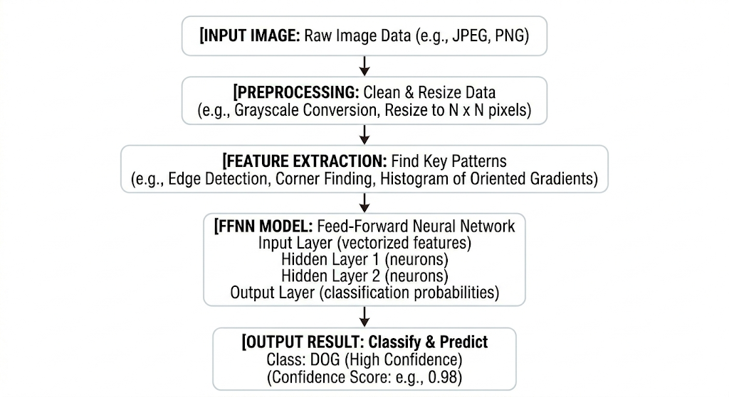
4.2 Use Case Diagram
The use case diagram describes the interaction between the user and the system.
Actors:
- User (Patient/Doctor)
Use Cases:
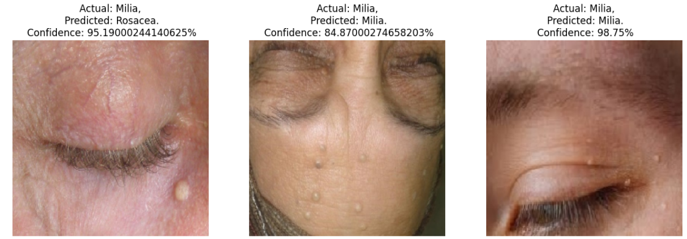
Description:
The user uploads an image of the affected skin area. The system processes the image and predicts the type of skin disease. The result is then displayed to the user.
4.3 Data Flow Diagram (DFD)
4.3.1 Level 0 DFD
(Level 0 shows the overall system as a single process)
Process: Skin Disease Detection System
Input: Skin Image
Output: Disease Prediction
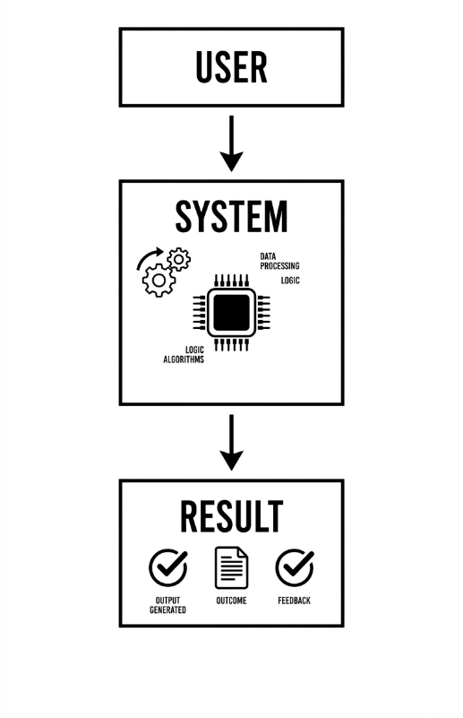
Flowchart:

4.3.2 Level 1 DFD
(Level 1 shows internal working in detail)
Processes: 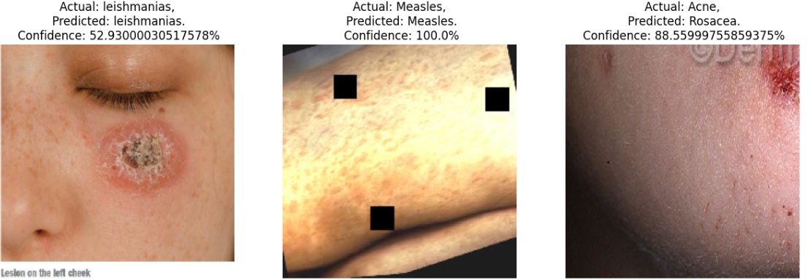
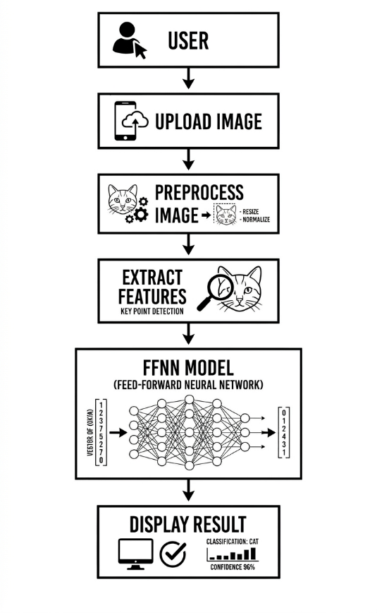
Flowchart:
4.4 Class Diagram
The class diagram represents the structure of the system by showing classes and their relationships.
Main Classes:
User
Attributes: userID, name
Methods: uploadImage()
ImageProcessor
Methods: preprocessImage(), extractFeatures()
Model (FFNN)
Methods: trainModel(), predict()
Result
Attributes: diseaseName, accuracy
Methods: displayResult()
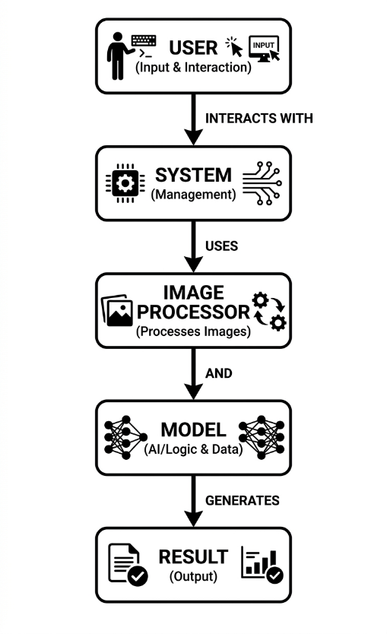
Relationship:
4.5 Database Design
The database is used to store user data and prediction results.
Tables:
- User Table
user_id (Primary Key)
name
- Image Table
image_id (Primary Key)
user_id (Foreign Key)
image_path
- Result Table
result_id (Primary Key)
image_id (Foreign Key)
disease_name
prediction_accuracy
Description:
The database maintains records of uploaded images and their corresponding predictions. This helps in tracking and improving the system performance.

Chapter 5: Implementation
5.1 Module Description
The system is divided into several modules to ensure efficient working and easy maintenance:
Image Input Module: Accepts skin images from the user or dataset.
Preprocessing Module: Enhances image quality by resizing, normalization, and noise removal.
Feature Extraction Module: Extracts important features such as color, texture, and patterns from images.
Classification Module: Uses the Feed Forward Neural Network (FFNN) to classify the skin disease.
Result Module: Displays the predicted disease along with accuracy.
5.2 Algorithm / Working Logic
Step 1: Start the system
Step 2: Input skin image
Step 3: Preprocess the image (resize, normalize)
Step 4: Extract features from the image
Step 5: Load trained FFNN model
Step 6: Pass features to the model
Step 7: Classify the disease
Step 8: Display result
Step 9: Stop
5.3 System Implementation (Code Snippets)
Below is a simple implementation using Python and neural network libraries:
5.4 Output Screenshots
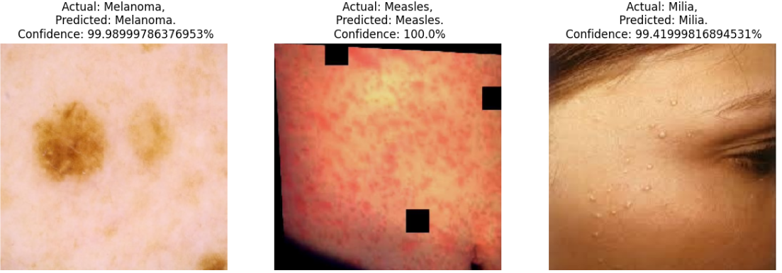

Chapter 6: Testing and Results
6.1 Test Plan
The purpose of testing is to ensure that the system works correctly and produces accurate results. The Skin Disease Detection System is tested using different input images to verify its performance, accuracy, and reliability.
The testing process includes:
Unit Testing: Testing individual modules such as image preprocessing and classification
Integration Testing: Ensuring all modules work together properly
System Testing: Testing the complete system with real-time inputs
Performance Testing: Evaluating system accuracy and response time
Test data consists of labelled skin disease images used to validate the predictions made by the model.
6.3 Test Results and Analysis
The system was tested with multiple skin images from the dataset to evaluate its performance. The results show that the model is capable of detecting and classifying skin diseases with good accuracy.
- The system successfully identified most of the skin diseases with minimal errors
- False positive and false negative rates were reduced compared to traditional methods
- The model performed well on clear and high-quality images
- Slight variations were observed when processing low-quality or unclear images
Overall, the system demonstrates reliable performance and can be used as a supportive tool for preliminary skin disease detection. With further improvements and larger datasets, the accuracy and efficiency of the system can be enhanced.

Chapter 7: System Evaluation and Future Scope
7.1 Advantages
The proposed Skin Disease Detection System offers several advantages:
Improved Accuracy: Uses neural network techniques to provide better classification results
Time Efficient: Reduces the time required for manual diagnosis
User-Friendly: Easy to use interface for uploading and analyzing images
Early Detection: Helps in identifying diseases at an early stage
Scalability: Can handle large datasets and can be extended easily
Automation: Minimizes human effort in the diagnosis process

7.2 Limitations
Despite its advantages, the system has some limitations:
Dependency on Data Quality: Accuracy depends on the quality of input images
Limited Dataset: Performance may decrease if trained on a small dataset
Misclassification Risk: Similar-looking diseases may sometimes be incorrectly classified
Computational Requirements: Neural network models may require good processing power
Not a Replacement for Doctors: It only assists and cannot fully replace professional medical diagnosis

7.3 Future Enhancements
The system can be further improved with the following enhancements:
Integration with mobile and web applications for easy accessibility
Use of advanced models like Convolutional Neural Networks (CNNs) for higher accuracy
Real-time detection using camera input
Integration with cloud storage for better data management
Addition of more disease categories and larger datasets
Implementation of multilingual support for wider usability

7.4 Applications
The proposed system can be applied in various fields:
Healthcare Centers and Clinics: Assisting doctors in diagnosis
Telemedicine: Remote diagnosis and consultation
Mobile Health Applications: Easy access for common users
Medical Research: Analysis of skin disease patterns
Rural Areas: Providing basic diagnostic support where specialists are not available

Chapter 8: Conclusion

The Skin Disease Detection System developed in this project demonstrates the effective use of Artificial Intelligence in the healthcare domain. The system utilizes a Feed Forward Neural Network (FFNN) to analyze skin images and classify different types of skin diseases with improved accuracy. By automating the detection process, the system reduces the dependency on manual diagnosis and minimizes the chances of human error.
The project successfully achieves its objectives by providing a fast, efficient, and user-friendly solution for preliminary skin disease identification. It also helps in reducing false positive and false negative rates compared to traditional methods. The system can serve as a supportive tool for healthcare professionals and can be further enhanced with advanced technologies and larger datasets.
In conclusion, the proposed system has the potential to improve diagnostic processes and contribute to better healthcare services. With future enhancements, it can become a reliable and widely used solution in real-world medical applications.

Chapter 9: References

[1] Mostafiz Ahammed , Md. Al Mamun , Mohammad Shorif Uddin . A machine learning approach for skin disease detection and classification using image segmentation (2022)
[2] Parvathaneni Naga Srinivasu , Jalluri Gnana SivaSai , Muhammad Fazal Ijaz, Akash Kumar Bhoi , Wonjoon Kim, James Jin Kang 6, Classification of Skin Disease Using Deep Learning Neural Networks with MobileNet V2 and LSTM (2021)
[3] Dimple Kapoor Deepali Gupta Yonis Gulzar, Mohannad Alkanan Mohammad Shuaib Mir Arjumand Bano Soomro Mudita Uppal and R. Reshma . Convolutional Neural Network-based Multi-Classification of Skin Disease with Fine-Tuned ResNet50 and VGG16 (2025)
[4] B. T. Woldemariam; T. T. Takore; M. Abdullah; B. Kedir. Image-Based Skin Diseases Detection and Classification Using Convolutional Neural Network (2024)
[5] Hui Liu, Yibo Dou, Kai Wang, Yunmin Zou, Gan Sen, Xiangtao Liu & Huling Li. A skin disease classification model based on multi scale combined efficient channel attention module (2025)
[6] Boddupelli Durgabhavani; Bollampelly Chandana; Sandhyarani; G. Lavanya; G. Srikanth; Nuthanakanti Bhaskar. Classification of Skin Disease using CNN (2023)
[7] Bisahu Ram Sahu; Akhilesh Kumar Shrivas; Abhinav Shukla. Skin Disease Classification using Machine Learning based Proposed Ensemble Model (2023)
[8] Mudiyam Sivani; M Shahina Parveen. Analysis on Skin Disease Segmentation and Classification using Machine Learning and Deep Learning in Dermoscopic Images (2025)
[9] Osim Kumar Pal. Skin Disease Classification: A Comparative Analysis of K-Nearest Neighbors (KNN) and Random Forest Algorithm (2021)

